Section 20: Application Programming Interfaces (API)

An **Application Programming Interface** (**API**) is a set of commands, functions, protocols, and objects that programmers can use to create software or interact with an external system.

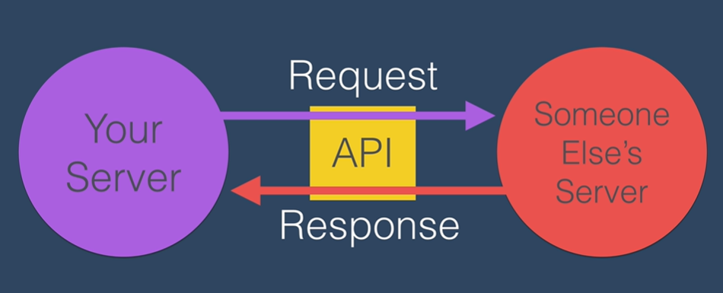

**Endpoint**: the point where you can access an API.

* The url

**Paths/Parameters** allow you to narrow down the information you want to get from a server.

* The url with a path or parameters added to the end of it
* Parameters are structured like this: ?*parameter1*=*value*&*parameter2*=*value*

**Authentication**: APIs require you to identify yourself

# Data

The data you receive from APIs are structured in different forms. The most common are JSON (JavaScript Object Notation) and XML.

The most common is JSON.

# Requests

We use a GET request to request data from a server. The API is like a menu that the server provides as a way to specify what things we need to pass over in order to get the response and data we want.

We can then incorporate this data in our website.